**Stinchcomb et al., 2016 paper results in R**

**Part 1: *Data used****:* geology_basic.csv

Ran PLSR model in R using oxide weight percentages (eg., Fe2O3_wt, Al2O3_wt...) and cl_MAP and cl_MAT

***Note: a) ln(Cao) was used***

***b) Data with zero values are not excluded from the analysis***

**Table 1:** PLSR model in R details

|  |  |
| --- | --- |
| PLS algorithm | NIPALS |
| Response variables | 2 (MAT and MAP) |
| Predictor variables | 11 (oxides) |
| Missing value handling | excluded |
| Number of factors | 4 |

|  |  |
| --- | --- |
| Number of observations used | 685 |

**Variance:**

|  |  |  |  |  |
| --- | --- | --- | --- | --- |
| Percent Variance explained by the PLSR model | | | | |
| Factors extracted | Predictor variables | | Dependent Variables | |
|  | Current | Total | Current | Total |
| 1 | 29.77 | 29.77 | 29.35 | 29.35 |
| 2 | 17.04 | 46.81 | 1.90 | 31.25 |
| 3 | 9.72 | 56.53 | 1.62 | 32.88 |
| 4 | 8.65 | 65.18 | 2.46 | 35.34 |

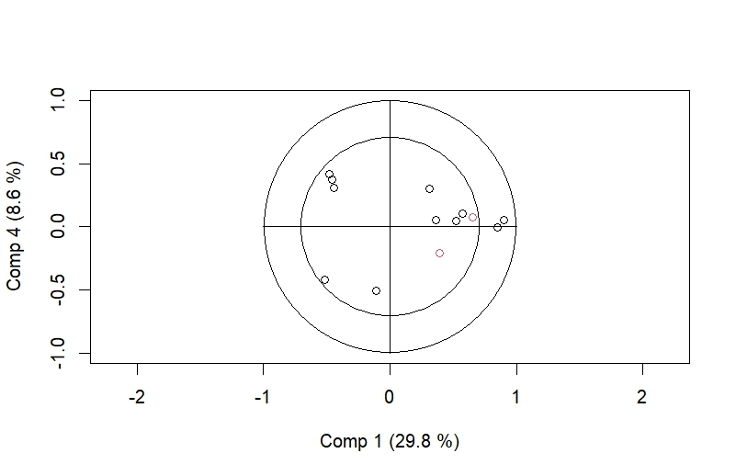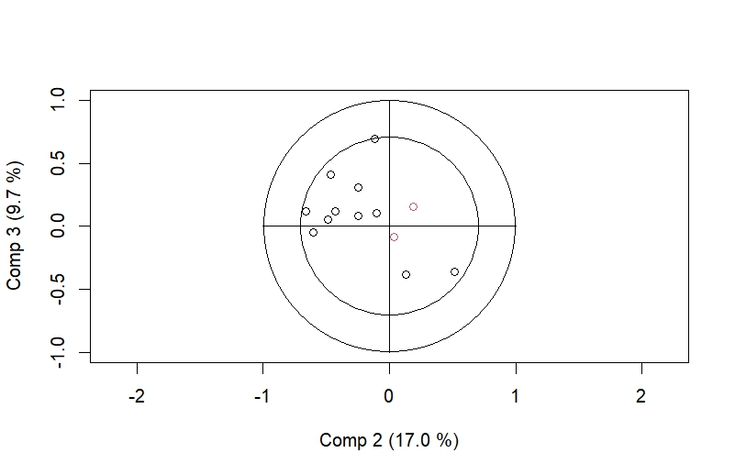

ln(CaO)

MnO

K2O

TiO2

Al2O3

P2O5

lCaO

Fe2O3

Na2O

SiO2

ZrO2

ZrO2

Al2O3

TiO2

Fe2O3

MAP

P2O5

MgO

K2O

SiO2

Na2O

MgO

MAP

MAT

MnO

MAT

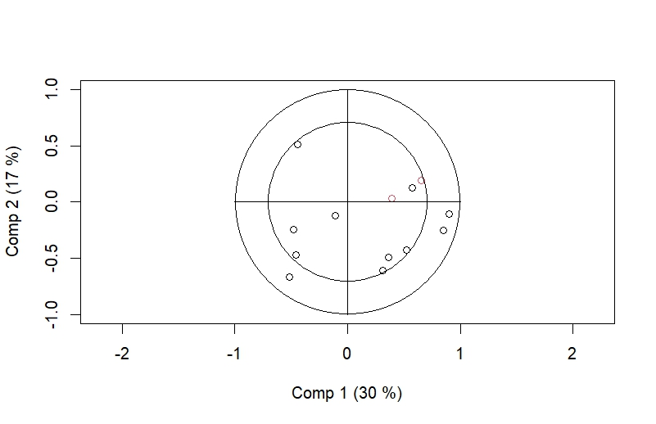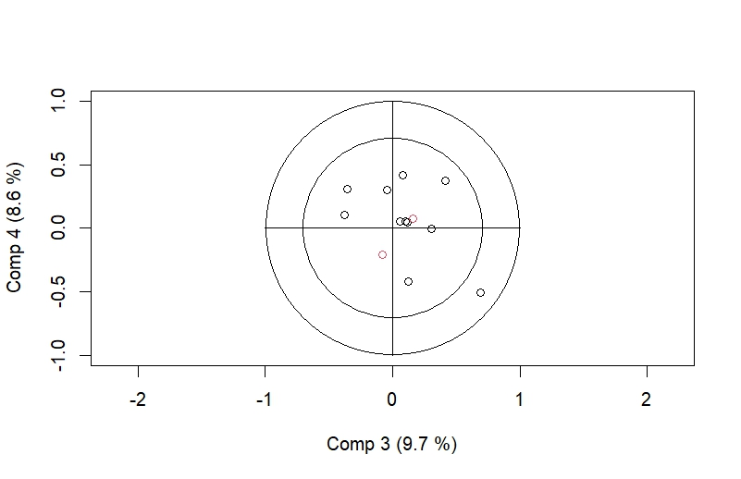

Al2O3

MnO

TiO2

Fe2O3

P2O5

ZrO2

K2O

Na2O

lCaO

ZrO2

TiO2

Fe2O3

Al2O3

P2O5

lCaO

Na2O

K2O

MgO

SiO2

SiO2

MAP

MAT

MgO

MAT

MAP

MnO

**Table 2:** Correlation coefficients, Pearson’s r for components 1-4 (C1-C4), oxides (wt%), MAP and MAT loadings

|  |  |  |  |  |  |  |
| --- | --- | --- | --- | --- | --- | --- |
|  | C1 | C2 | C3 | C4 | MAP | MAT |
| Fe2O3 | 0.85 | -0.25 | 0.31 | -0.01 | 0.55 | 0.30 |
| MnO | 0.36 | -0.49 | 0.06 | 0.05 | 0.16 | 0.08 |
| P2O5 | 0.31 | -0.60 | -0.04 | 0.30 | 0.11 | 0.05 |
| SiO2 | -0.44 | 0.51 | -0.36 | 0.31 | -0.25 | -0.25 |
| TiO2 | 0.90 | -0.10 | 0.10 | 0.05 | 0.60 | 0.33 |
| ZrO2 | 0.57 | 0.13 | -0.38 | 0.10 | 0.34 | 0.12 |
| Al2O3 | 0.52 | -0.43 | 0.12 | 0.05 | 0.27 | 0.19 |
| Na2O | -0.49 | -0.46 | 0.41 | 0.37 | -0.30 | -0.36 |
| K2O | -0.48 | -0.24 | 0.08 | 0.42 | -0.33 | -0.33 |
| MgO | -0.11 | -0.12 | 0.69 | -0.51 | -0.02 | -0.06 |
| ln(CaO) | -0.51 | -0.66 | 0.12 | -0.42 | -0.47 | -0.15 |
| MAP | 0.66 | 0.19 | 0.16 | 0.08 |  |  |
| MAT | 0.39 | 0.03 | -0.08 | -0.21 |  |  |

Note: Running PLSR using molar concentrations or weight percentages didn’t show any variation in the results, however, there is a little variation observed in correlation coefficients running the model using CaO vs ln(CaO)

* The correlation loading plot between components (or factors) 1 and 4 was closer to the Stinchcomb et al., 2016 paper
* Component 1 is similar to the regressor 1 in Stinchcomb paper
* The Pearson correlation coefficient between MAP, MAT, and component 1 is similar to the Stinchcomb paper but the rest are a bit different

Results from Stinchcomb et al., 2016

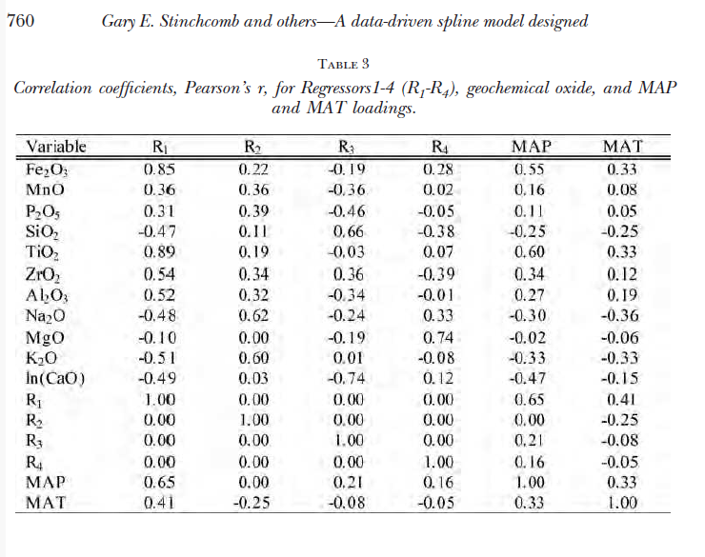

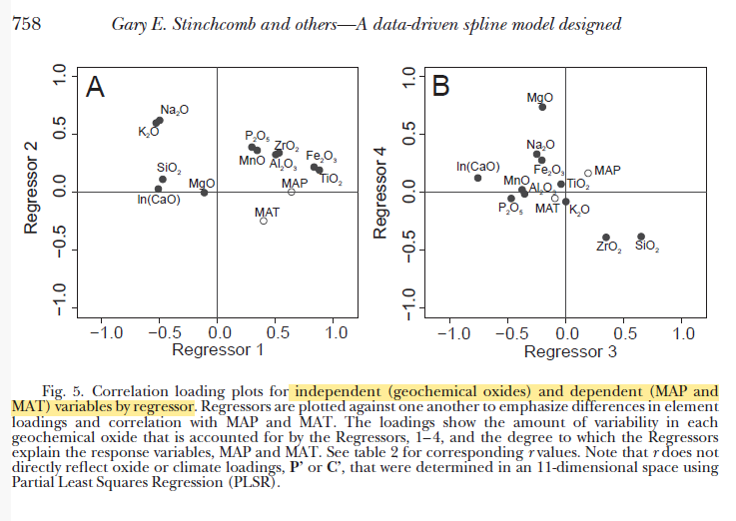

**Part 2**: ***Data used***: ppm1_data.sas7bdat from the sas data uploaded by Jack in Github

Ran PLSR model in R using oxide molar concentrations (eg., Fe2O3_mol, Al2O3_mol...) and cl_MAP and cl_MAT

***Note: a) Cao_mol was used in this section instead of ln(CaO_mol)***

***b) Data with zero values are not excluded from the analysis***

**Table 1:** PLSR model in R details

|  |  |
| --- | --- |
| PLS algorithm | NIPALS |
| Response variables | 2 (MAT and MAP) |
| Predictor variables | 11 (oxides) |
| Missing value handling | excluded |
| Number of factors | 4 |

|  |  |
| --- | --- |
| Number of observations used | 685 |

**Variance:**

|  |  |  |  |  |
| --- | --- | --- | --- | --- |
| Percent Variance explained by the PLSR model | | | | |
| Factors extracted | Predictor variables | | Dependent Variables | |
|  | Current | Total | Current | Total |
| 1 | 27.62 | 27.62 | 27.16 | 27.16 |
| 2 | 14.89 | 42.51 | 3.54 | 30.70 |
| 3 | 8.79 | 51.30 | 1.23 | 31.94 |
| 4 | 6.48 | 57.78 | 1.43 | 33.37 |

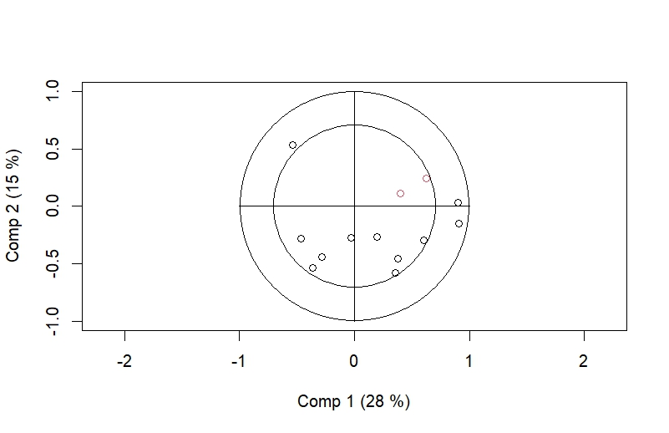

ZrO2

MgO

K2O

CaO

Na2O

MnO

P2O5

TiO2

Fe2O3

MAP

MAT

SiO2

Al2O3

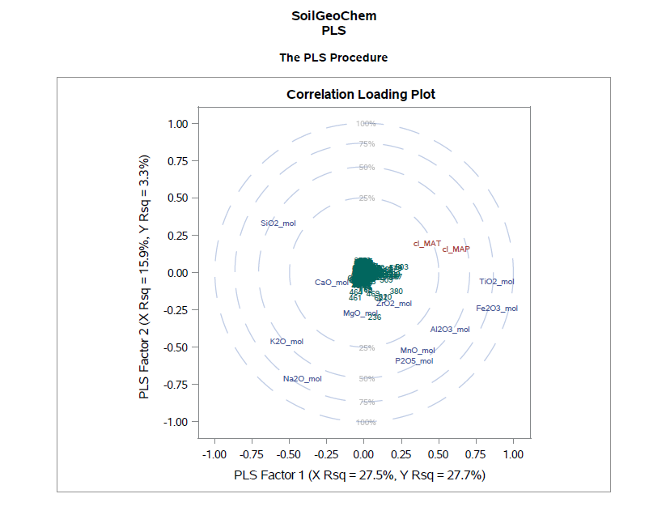

* The correlation loading plot ran in R using sas data was similar to the sas generated plot, expect for CaO. The variance (Table 1) is also similar to sas one
* I used the same data that was used in sas to generate the above figure in R

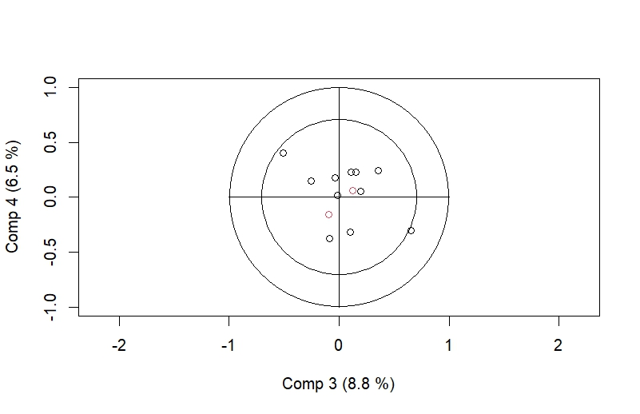

K2O

Fe2O3

Na2O

TiO2

MAP

P2O5

MnO

MgO

CaO

MAT

Al2O3

SiO2

ZrO2

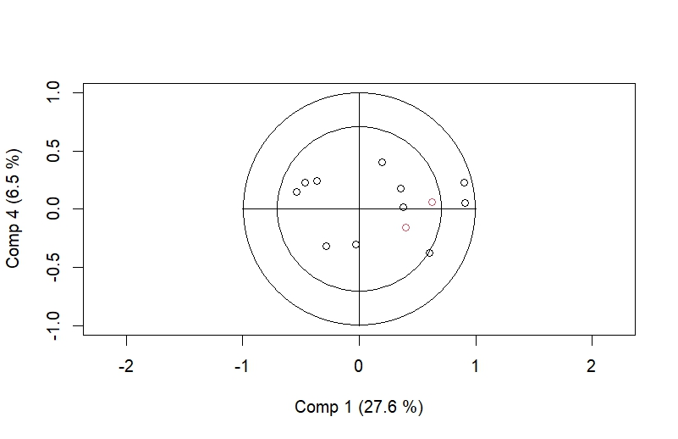

Al2O3

Fe2O3

TiO2

MnO

P2O5

MAP

MAT

ZrO2

MgO

CaO

Na2O

K2O

SiO2

**Table 2:** Correlation coefficients, Pearson’s r for components 1-4 (C1-C4), oxides, MAP and MAT loadings

|  |  |  |  |  |  |  |
| --- | --- | --- | --- | --- | --- | --- |
|  | C1 | C2 | C3 | C4 | MAP | MAT |
| Fe2O3 | 0.91 | -0.17 | 0.26 | 0.06 | 0.55 | 0.30 |
| MnO | 0.38 | -0.48 | -0.05 | 0.004 | 0.16 | 0.08 |
| P2O5 | 0.35 | -0.59 | -0.11 | 0.19 | 0.11 | 0.05 |
| SiO2 | -0.54 | -0.50 | -0.35 | 0.36 | -0.25 | -0.25 |
| TiO2 | 0.90 | 0.009 | 0.07 | 0.11 | 0.60 | 0.33 |
| ZrO2 | 0.19 | 0.21 | -0.52 | 0.06 | 0.31 | 0.10 |
| Al2O3 | 0.60 | -0.39 | -0.01 | 0.06 | 0.27 | 0.19 |
| Na2O | -0.36 | -0.55 | 0.26 | 0.34 | -0.30 | -0.36 |
| K2O | -0.47 | -0.35 | -0.07 | 0.51 | -0.33 | -0.33 |
| MgO | -0.02 | -0.19 | 0.69 | -0.37 | -0.02 | -0.06 |
| CaO | -0.28 | -0.38 | 0.07 | -0.68 | -0.28 | 0.02 |
| MAP | 0.62 | 0.24 | 0.13 | 0.06 |  |  |
| MAT | 0.40 | 0.11 | -0.09 | -0.16 |  |  |